Flowchart

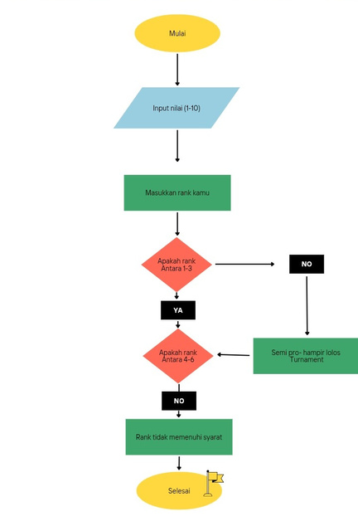

B. Codingan
- rank = int(input("Masukkan rank kamu (1-10): "))

- if rank >= 1 and rank <= 3:
- print("Pro Player - Lolos Turnamen")
- elif rank >= 4 and rank <= 6:
- print(" Semi Pro - Hampir Lolos turnament)
- elif rank >= 7 and rank <= 10:
- print("Beginner - Tidak Lolos Turnamen")
- else:
- print("Rank tidak memenuhi syarat")
